**Github.com**

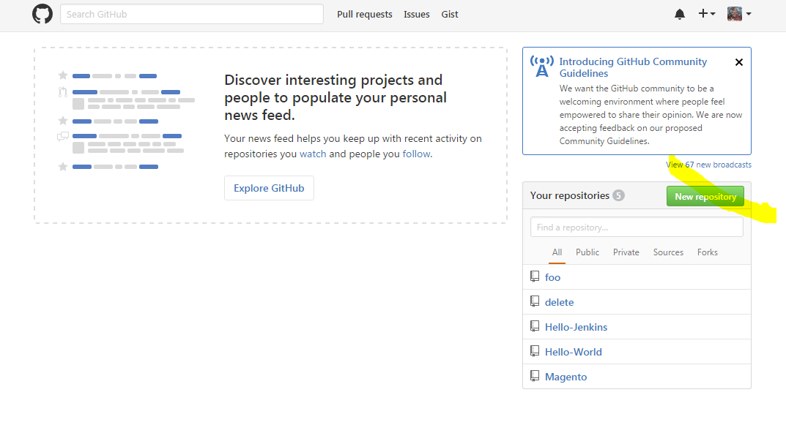

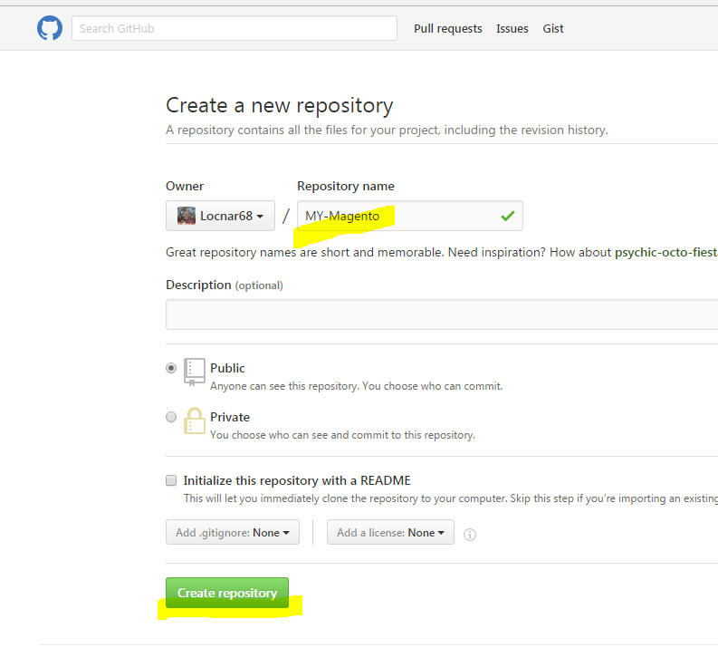

**Push your Magento Data up to GitHub**

Your BITNAMI - Magento Home directory is /opt/bitnami/apps/magento/htdocs

* NOTE: This is not the default Magento directory for fresh installs

1. cd /opt/bitnami/apps/magento/htdocs

**Replace <https://github.com/Locnar68/Magento.git> with your github repo

sudo git init

sudo git status

sudo git add .

sudo git status

sudo git remote add origin <https://github.com/Locnar68/Magento.git>

sudo git commit –m “This is my forst Commit to my git Repo”

sudo git push origin master

sudo git status

----------------------------------------------------

# **Basic Git commands**

Here is a list of some basic Git commands to get you going with Git.

For more detail, check out the [**Atlassian Git Tutorials**](http://atlassian.com/git?utm_source=basic-git-commands&utm_medium=link&utm_campaign=git-microsite) for a visual introduction to Git commands and workflows, including examples.

|  |  |  |
| --- | --- | --- |
| **Git task** | **Notes** | **Git commands** |
| [**Tell Git who you are**](https://www.atlassian.com/git/tutorials/setting-up-a-repository/git-config) | Configure the author name and email address to be used with your commits.  Note that Git [strips some characters](http://stackoverflow.com/questions/26159274/is-it-possible-to-have-a-trailing-period-in-user-name-in-git/26219423#26219423) (for example trailing periods) from user.name. | git config --global user.name "Sam Smith"  git config --global user.email sam@example.com |
| [**Create a new local repository**](http://atlassian.com/git/tutorial/git-basics#!init) |  | git init |
| [**Check out a repository**](http://atlassian.com/git/tutorial/git-basics#!clone) | Create a working copy of a local repository: | git clone /path/to/repository |
| For a remote server, use: | git clone username@host:/path/to/repository |
| [**Add files**](http://atlassian.com/git/tutorial/git-basics#!add) | Add one or more files to staging (index): | git add <filename>  git add * |
| [**Commit**](http://atlassian.com/git/tutorial/git-basics#!commit) | Commit changes to head (but not yet to the remote repository): | git commit -m "Commit message" |
| Commit any files you've added with git add, and also commit any files you've changed since then: | git commit -a |
| [**Push**](http://atlassian.com/git/tutorial/remote-repositories#!push) | Send changes to the master branch of your remote repository: | git push origin master |
| [**Status**](http://atlassian.com/git/tutorial/git-basics#!status) | List the files you've changed and those you still need to add or commit: | git status |
| [**Connect to a remote repository**](http://atlassian.com/git/tutorial/remote-repositories#!remote) | If you haven't connected your local repository to a remote server, add the server to be able to push to it: | git remote add origin <server> |
| List all currently configured remote repositories: | git remote -v |
| [**Branches**](http://atlassian.com/git/tutorial/git-branches) | Create a new branch and switch to it: | git checkout -b <branchname> |
| Switch from one branch to another: | git checkout <branchname> |
| List all the branches in your repo, and also tell you what branch you're currently in: | git branch |
| Delete the feature branch: | git branch -d <branchname> |
| Push the branch to your remote repository, so others can use it: | git push origin <branchname> |
| Push all branches to your remote repository: | git push --all origin |
| Delete a branch on your remote repository: | git push origin :<branchname> |
| [**Update from the remote repository**](http://atlassian.com/git/tutorial/remote-repositories) | Fetch and merge changes on the remote server to your working directory: | git pull |
| To merge a different branch into your active branch: | git merge <branchname> |
| View all the merge conflicts:  View the conflicts against the base file:  Preview changes, before merging: | git diff  git diff --base <filename>  git diff <sourcebranch> <targetbranch> |
| After you have manually resolved any conflicts, you mark the changed file: | git add <filename> |
| **Tags** | You can use tagging to mark a significant changeset, such as a release: | git tag 1.0.0 <commitID> |
| CommitId is the leading characters of the changeset ID, up to 10, but must be unique. Get the ID using: | git log |
| Push all tags to remote repository: | git push --tags origin |
| [**Undo local changes**](http://atlassian.com/git/tutorial/undoing-changes) | If you mess up, you can replace the changes in your working tree with the last content in head:  Changes already added to the index, as well as new files, will be kept. | git checkout -- <filename> |
| Instead, to drop all your local changes and commits, fetch the latest history from the server and point your local master branch at it, do this: | git fetch origin  git reset --hard origin/master |
| **Search** | Search the working directory for foo(): | git grep "foo()" |